**Talend – Purchasing DW**

DimDate

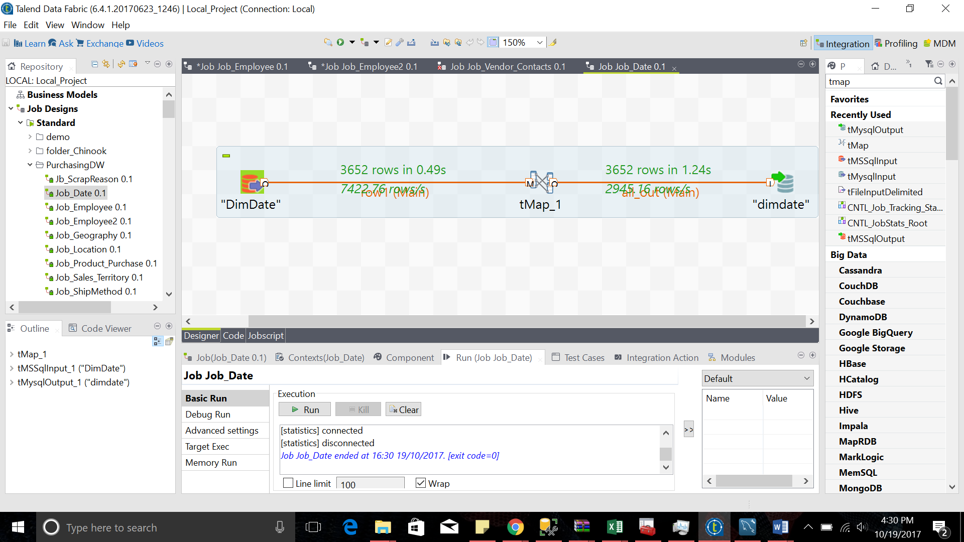

Output Rows: 3652

DimScrapeReason

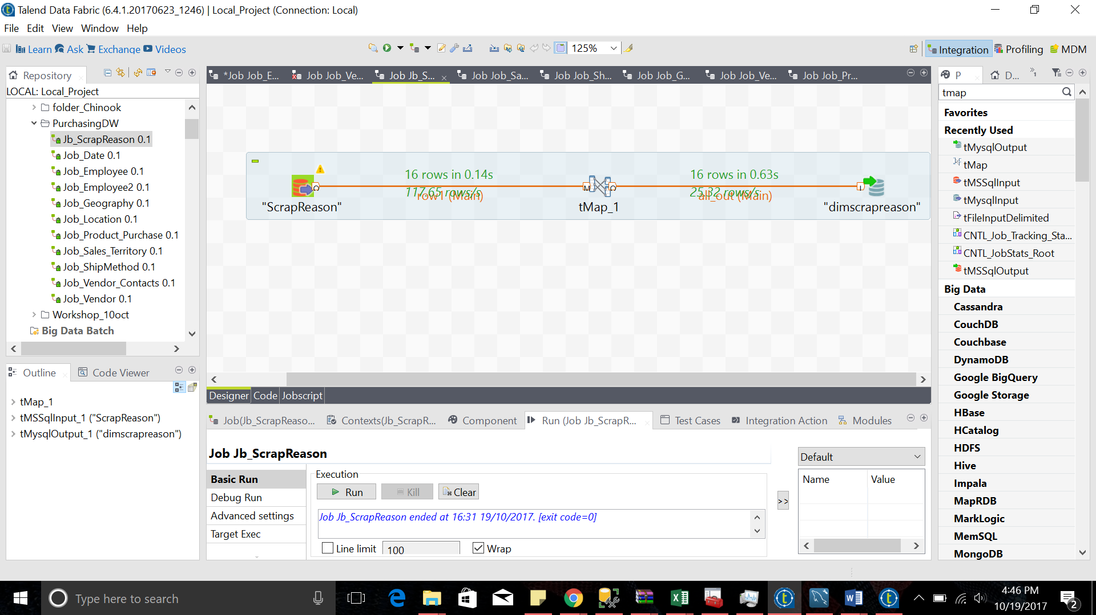

Output Rows: 16

DimLocation

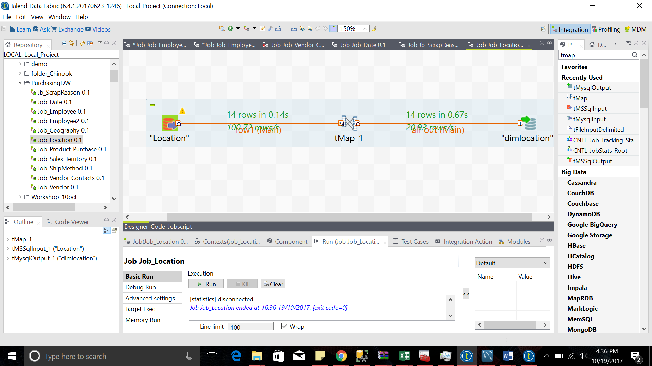

Output Rows: 14

DimSalesTerritory

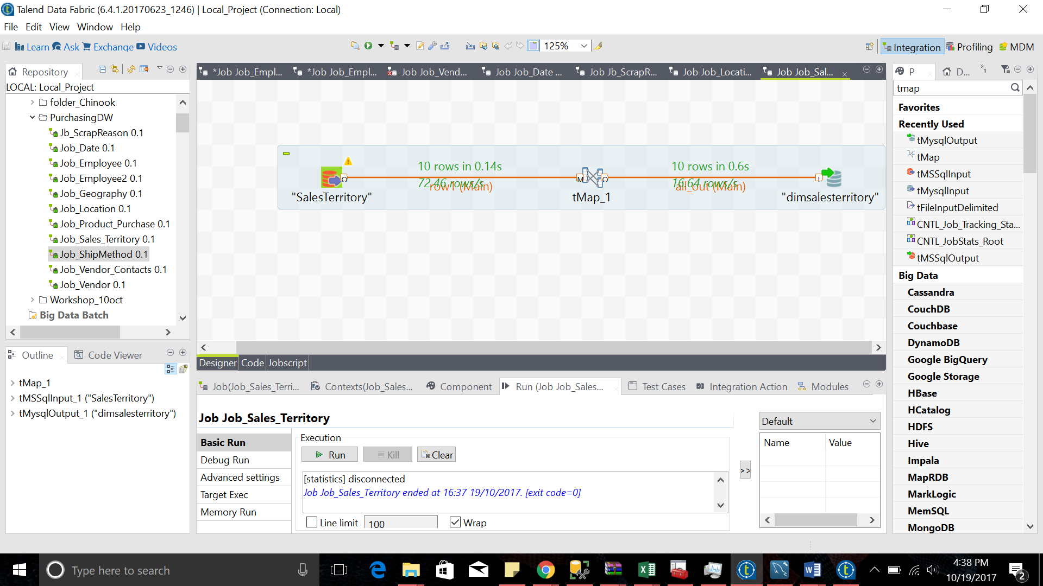

Output Rows: 10

DimShipMethod

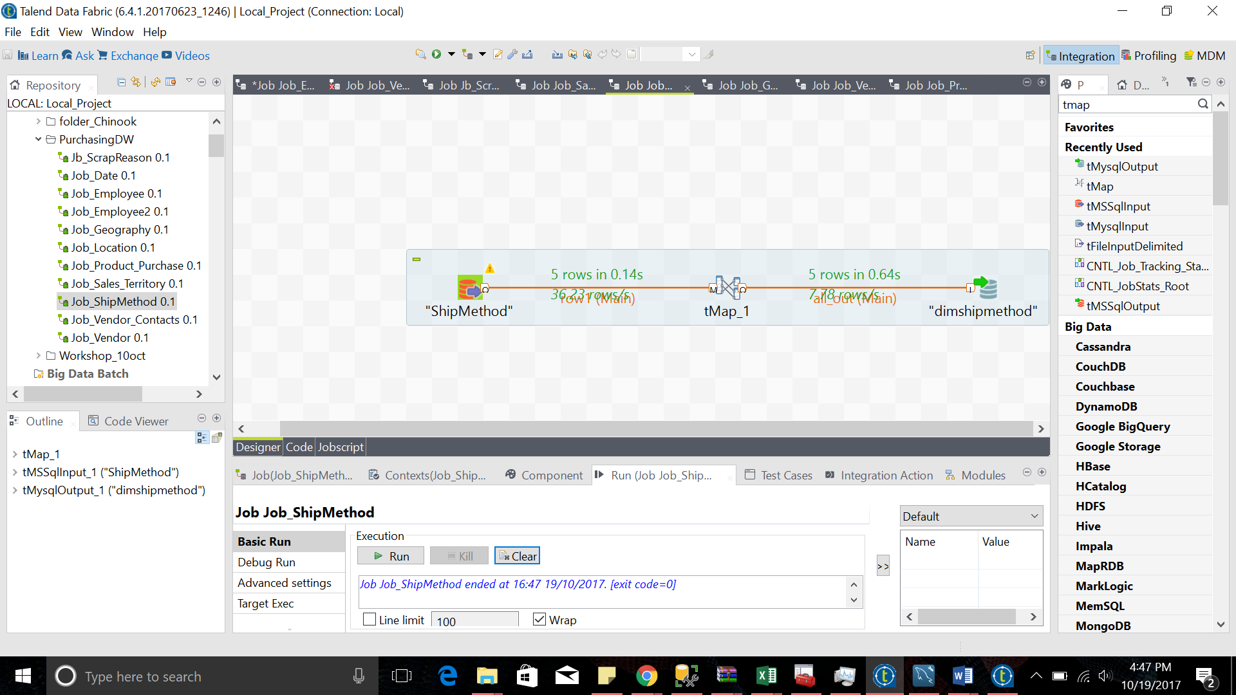

Output Rows: 5

DimGeography

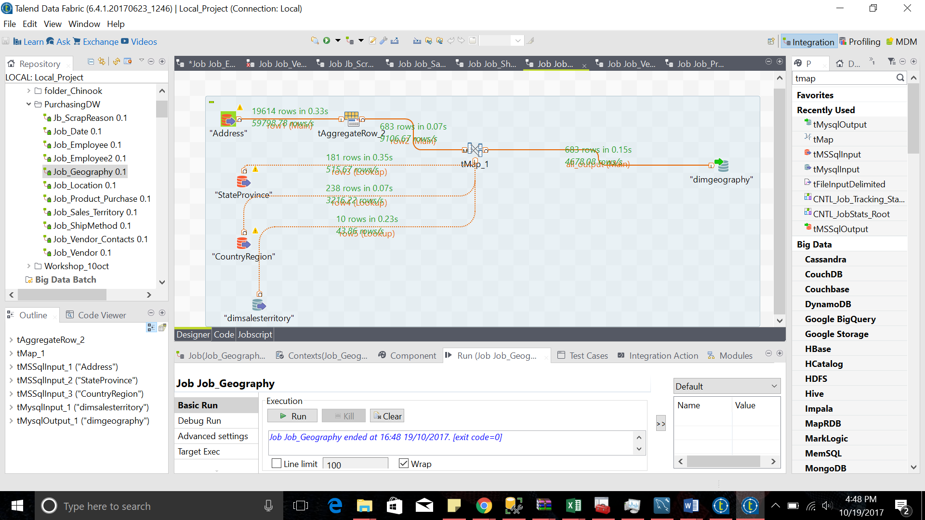

Output Rows: 683

DimVendors

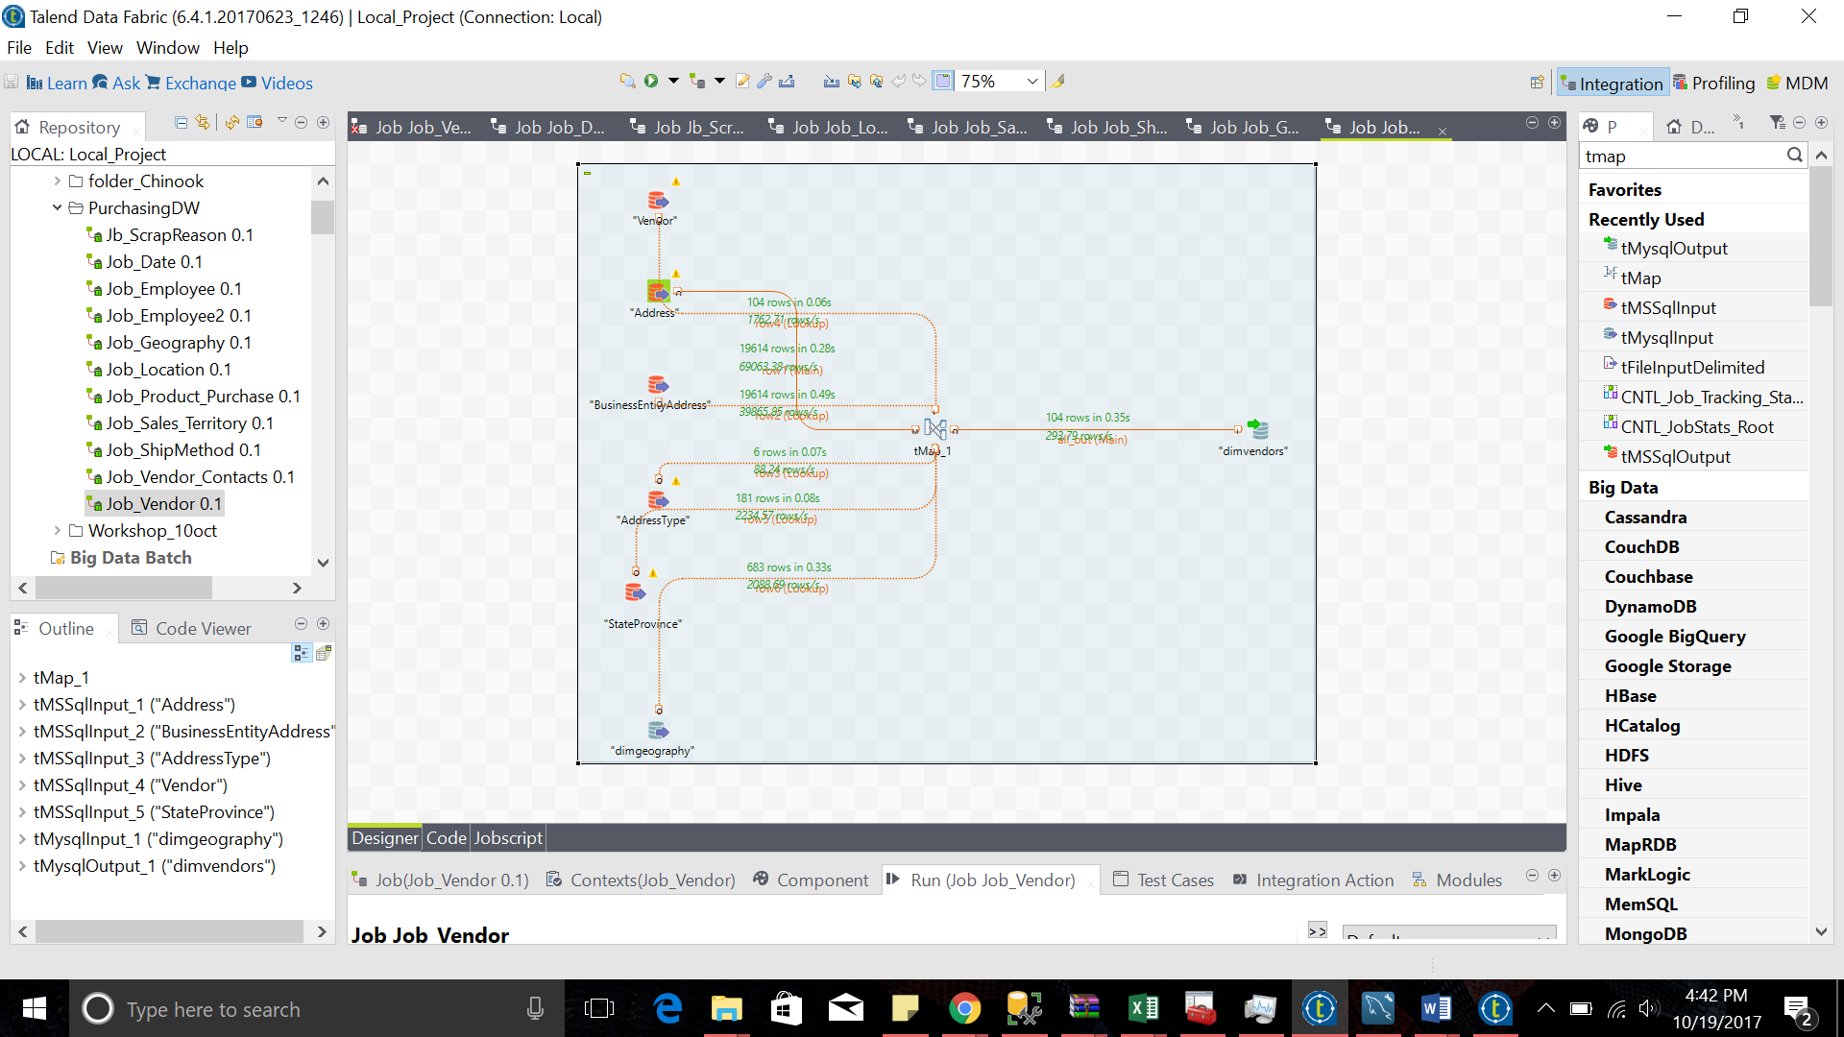

Output Rows: 104

DimEmployee

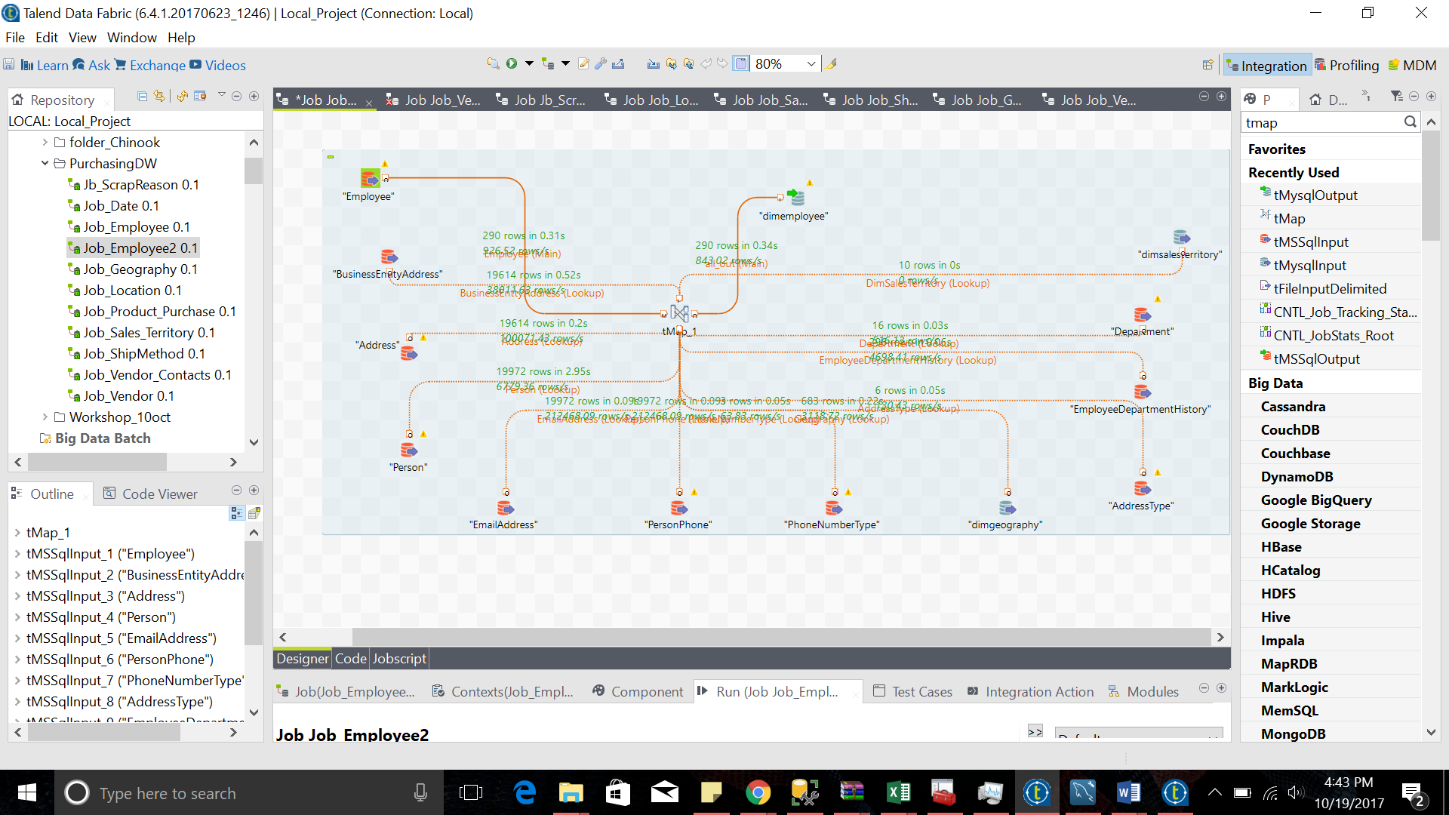

Output Rows: 290

DimProduct_Purchase

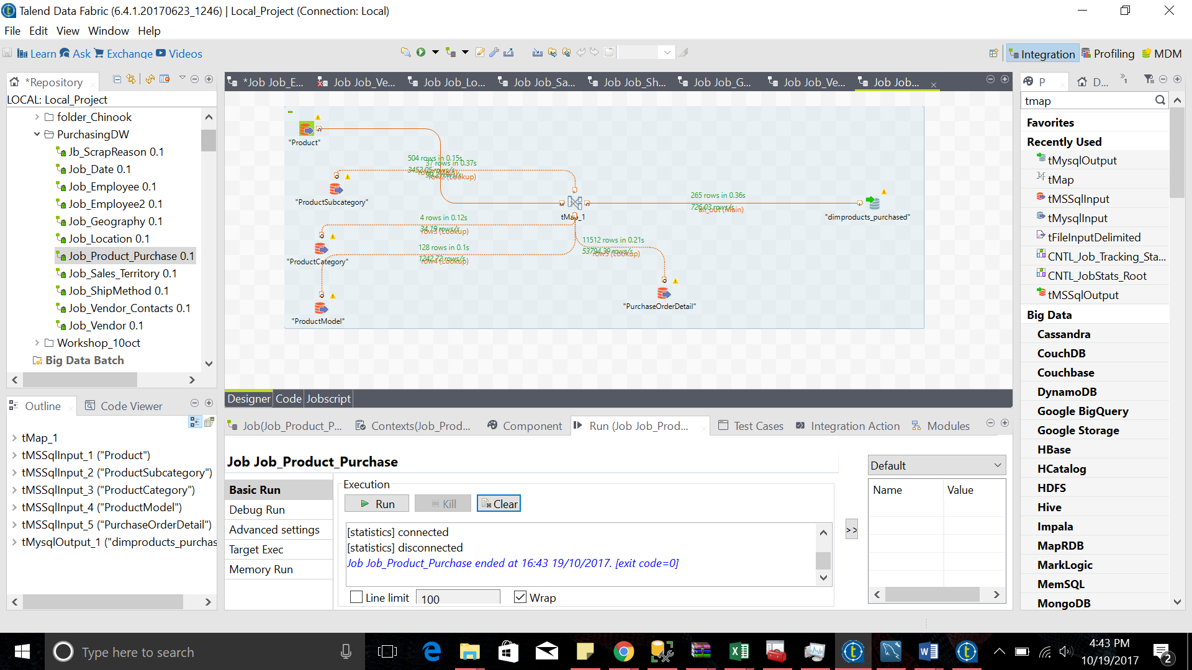

Output Rows: 285

DimVendorContacts

